INFORMATION SHEET
Preventing falls from height for low risk, short duration task
This information sheet is for tasks that are considered low risk, short duration tasks; as a general rule this would be considered as a task that involves using a ladder, step ladder or kick stool for less than 30 minutes. It outlines the precautions that should be taken to keep people safe in the workplace.
A number of activities carried out in the work place can be considered as low risk day to day today activities, but the use of inadequate or inappropriate equipment can lead to serious injury. For example consider a person standing on a chair to reach a heavy object on the top shelf in an office, chairs are not designed to be stood on and could collapse or move when the colleague is retrieving the object.
What can we do?....
Can you avoid working at Height?
This is the best way to avoid the risk of falls from height, however this is not always possible.
What else can we do to reduce this risk?
- Reduce the frequency the task is carried out – store regularly used equipment at low levels that can be easily accessed from the floor.
- Use appropriate equipment such as ladder / step ladder or kick stool, following pre-use check and training.
- Do not use furniture e.g. chairs, desk that are not designed for standing on.
- Always seek assistance if you cannot reach an item safely
- Do not lean or over stretch, move equipment to a suitable position to avoid unnecessary injury
- Ensure environment is free from obstacles and equipment can be used safely
- Ensure you are not endangering others and yourself when carrying out your activity.

All checks should be carried out and recorded prior to use. All ladders and kick stools should be clearly identified and an inventory list held.
Using a Step ladder
To use a Step Ladder you need to be competent i.e. have received instruction and understand how to use it safely. These checks should have the date the inspection is carried out, by who, clearly legible and visible on the ladder

When using a ladder you should ensure
- All four stepladder feet are in contact with the ground and the steps are level;
- Only use a step ladder to carryout light work tasks and only light materials and tools should be used
- Do not overreach, over extend, the ladder should be repositioned to carry out the task

- Do not stand and work on the top three steps (including a step forming the very top of the stepladder) unless there is a suitable handhold;
- Ensure any locking mechanism is engaged
- The stepladder should be positioned so the user is facing the work activity and not side on. However, there are occasions when a risk assessment may show it is safer to work side on
- Maintain three points of contact at the working position. This means two feet and one hand, or when both hands need to be free for a brief period, two feet and the body supported by the stepladder.

Pre Use Check
The pre-use checks should be carried out
- By the user prior to use
- If the ladder has been dropped or moved etc.
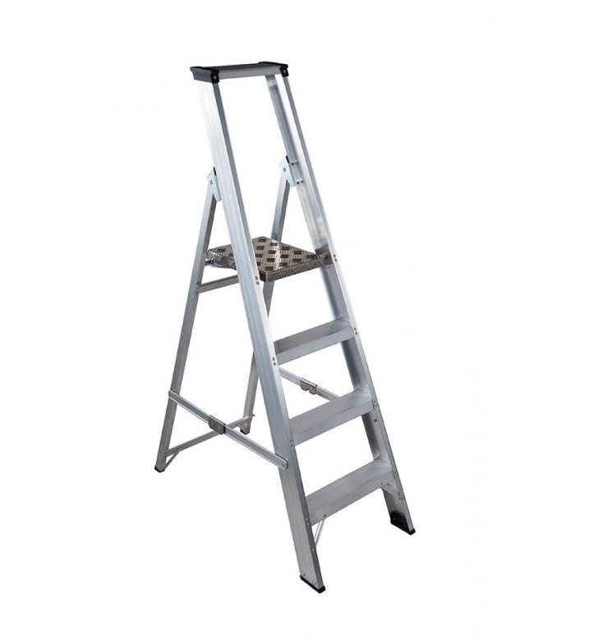
5. Locking Mechanism
1. Stiles
2. Platform
3. rung / steps
4. Feet
The following should be checked
- Stiles – ensure stiles are not bent /damaged this can cause the ladder to buckle or collapse.
- Step Ladder Platform – is it split, buckled etc. if so the ladder could become unstable or collapse
- Rungs / steps – if bent, worn, loose or missing the ladder could fall or collapse. Are they contaminated? This can make them slippery
- Feet – Are they intact, missing or worn? If so it could cause the ladder to slip. Check all 4 feet are in contact with the ground and are level and are not contaminated before use.
- Locking Mechanism – if bent or fixings are worn or damaged the ladder could collapse. Ensure the locking bars are engaged before using.

If any defects are noted DO NOT use the step ladder, remove it from use and report to supervisor
.
Using a Kick Stool
Kick stool do not have the same stability issues as a ladder and are designed not to move when weight is applied. All kick stool should be clearly identified and recorded on a kick stool register, they should be checked prior to use and subject to a bi-annual check to ensure they are suitable for use. Any kick stools found to be defective should be removed from service immediately and reported to the supervisor.

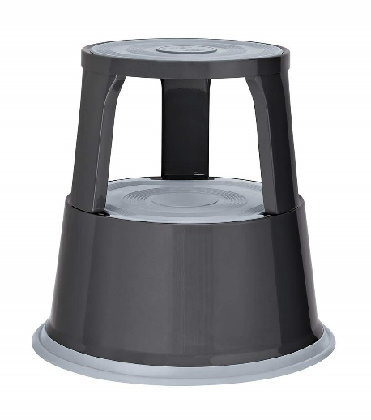
When using a kick stool you should ensure:
- No obstructions in path of kick stool
- When kicking the stool make sure to kick the base
- Only use when it has stopped moving
- Step up onto stool 1 foot at time, may need to hold onto something / one for balance
- Stand in centre of stool (some stools do not have spring loaded castors which stops the stool moving when a weight is applied)
- Make sure you can reach item – do not over extend / stretch, move stool closer
- Do not use if lifting heavy or large awkward objects
- To dismount make sure to step one step at a time, do not rush, or jump off the kick stool could give way underneath and cause user to fall
- Make sure you wear appropriate foot wear that will not slip on the step. Appropriate clothing that will not will not cause and obstruction or trip hazard when mounting and dismounting the stool.

Pre-use Check
- Assess the condition of the kick stool - Are the significant dents, loose parts or evidence of corrosion
- Tap the kick stool with your foot - Does it move freely, does it veer to left or right, does it make a noise when it is moved?
- Check the rubber ring at the base - Is this fixed into place and around the bottom rim?
- Check the rubber surfaces of step – are they loose, heavily contaminated?
- Does the stool engage when you stand on it?
Bi-annual Check
- Assess the condition of the kick stool - Are the significant dents, loose parts or evidence of corrosion
- Tap the kick stool with your foot - Does it move freely, does it veer to left or right, does it make a noise when it is moved?
- Check the rubber ring at the base - Is this fixed into place and around the bottom rim?
- Check the rubber surfaces of step – are they loose, heavily contaminated?
- Does the stool engage when you stand on it?
- Wheel and Axle – are all 3 wheel present, is there contamination on the wheel and axle, are the wheels in good condition, do they move freely
- Wheel Spring – is it present, free from contamination and corrosion? Does it move up and down when pressed
If any defects are noted DO NOT use the Kick Stool, remove it from use and report to supervisor

For further information:
- Please contact H&S team: healthandsafety@swansea.ac.uk
- INDG401 – Working at height guide. http://www.hse.gov.uk/pUbns/indg401.pdf
- INDG453 – Safe Use of Ladders. http://www.hse.gov.uk/pubns/indg455.htm
- Working at Height Regulations 2005. http://www.legislation.gov.uk/uksi/2005/735/contents/made

1. | Name 3 ways to reduce the risks of working at height
2. | When should a ladder check be carried out
3. | What checks should be carried out on a ladder
4. | Name 3 things you should ensure when using a kick stool

Name:____________________________________________________________________Print & Sign

Date:___________________________________

