INSPECTION / PRE-USE CHECK OF LADDERS

InTRODUCTION
To use a ladder you need to be competent i.e. have received instruction and understand how to use it safely. Ladders should be checked prior to use and subject to a monthly check to ensure they are suitable for use. All ladders should be clearly identified and recorded on a ladder register. Any ladders found to be defective should be removed from service immediately and reported to the supervisor.

pre-use check

To use a Ladder you need to be competent i.e. have received instruction and understand how to use it safely. These checks should have the date the inspection is carried out, by who, clearly legible and visible on the ladder
- Stiles – make sure they are not bent or damaged, as the ladder could buckle or collapse.
Stiles
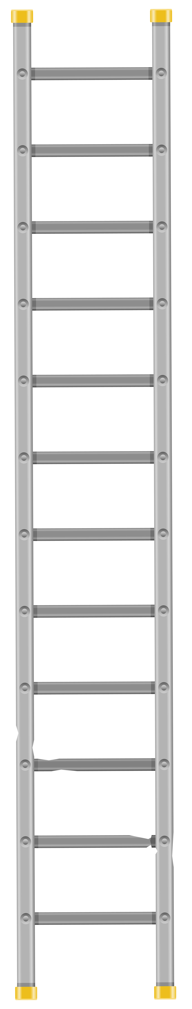
- Feet – if they are missing, worn or damaged the ladder could slip. Also check ladder feet when moving from soft/dirty ground (e.g. dug soil, loose sand/ stone, a dirty workshop) to a smooth, solid surface (e.g. paving slabs), to make sure the foot material and not the dirt (e.g. soil, chippings or embedded stones) is making contact with the ground.
Rungs

- Rungs – if they are bent, worn, missing or loose the ladder could fail.
- Any locking mechanisms – if they are bent or the fixings are worn or damaged the ladder could collapse. Ensure any locking bars are engaged.
Steps / treads
- The steps or treads on ladders – if they are contaminated they could be slippery; if the fixings are loose on steps, they could collapse. If you spot any of the above defects, don’t use the ladder and notify your employer.

Any ladders that fail the inspection should be removed and disposed of correctly.

Monthly Check Sheet

LADDER INSPECTION SHEET

Name
Date
Checked By
 | Checked | Comments
Stiles – ensure stiles are not bent /damaged this can cause the ladder to buckle or collapse.
Step Ladder Platform – is it split, buckled etc. if so the ladder could become unstable or collapse
Rungs / steps – if bent, worn, loose or missing the ladder could fall or collapse. Are they contaminated? This can make them slippery
Feet – Are they intact, missing or worn? If so it could cause the ladder to slip. Check all 4 feet are in contact with the ground and are level and are not contaminated before use.
Locking Mechanism – if bent or fixings are worn or damaged the ladder could collapse. Ensure the locking bars are engaged before using.

Any ladders that fail the inspection should be removed, reported to your supervisor and disposed of correctly.

Signed______________________

