INFORMATION SHEET
Working at height: Safe use of ladders
Falls from height are one of the biggest causes of workplace fatalities and major injuries. Common causes are falls from ladders and through fragile roofs. This information sheet outlines the precautions that should be taken when using ladders to prevent such accidents.
Working at height (WAH) means work in any place, if there were no precautions in place and a person could fall a distance liable to cause personal injury. E.g.
- Ladder or on a fall roof
- Fall through a fragile surface
- A person could fall into an opening on the floor or hole in the ground.
What do you need to consider when planning work at height?
- The following are all requirements in law that you need to consider when planning and undertaking work at height.
- You must:
- Take account of weather conditions that could compromise worker safety;
- Check that the place (e.g. a roof) where work at height is to be undertaken is safe. Each place where people will work at height needs to be checked every time, before use;
- Stop materials or objects from falling or, if it is not reasonably practicable to prevent objects falling, take suitable and sufficient measures to make sure no one can be injured, e.g. use exclusion zones to keep people away or mesh on scaffold to stop materials such as bricks falling off;
- Store materials and objects safely so they won’t cause injury if they are disturbed or collapse;
Before carrying out work you should
- Avoid work where practicable
- Where it cannot be avoided, prevent falls using either an existing place of work that is already safe or the right type of equipment
- Minimise the distance and consequence of a fall, using the right type of equipment where risk cannot be eliminated.
- Only authorised personnel who are trained and competent should work at height.
- All relevant permits should be obtained before carrying out any work. E.g. roof work
When is a ladder the most sensible option?
The law states a ladder can be used to work at height when a risk assessment has shown higher level fall protection is not justified because of the low risk and short duration of the task or existing work place features cannot be altered.
As a general rule if a task would require working up a ladder for more than 30 minutes at a time, then alternative equipment should be considered. However, short duration should not be the deciding factor to determine if a ladder is suitable, the risk should be considered first.

Using a Step ladder – see low level fall information sheet

Ladders
To use a Ladder you need to be competent i.e. have received instruction and understand how to use it safely. The ladder should also be checked prior to use. These checks should have the date the inspection is carried out, by who, clearly legible and visible on the ladder
- Need to make sure that any ladder or stepladder is both suitable for the work task and in a safe condition before use. As a guide, only use ladders:
- No visible defects. They should have a pre-use check each working day,(WH002 Ladder pre-use check)
- An up-to-date record of the detailed visual inspections carried out regularly by a competent person. These should be done in accordance with the manufacturer’s instructions. Ladders that are part of a scaffold system still have to be inspected every seven days as part of the scaffold inspection requirements;
- Are suitable for the intended use, i.e. are strong and robust enough for the job. HSE recommends British Standard (BS) Class 1 ‘Industrial’ or BS EN 131 ladders for use at work
- Have been maintained and stored in accordance with the manufacturer’s instructions.

Pre-Use Checks
To carry out a pre-se check you should check
- Stiles – make sure they are not bent or damaged, as the ladder could buckle or collapse.
- Feet – if they are missing, worn or damaged the ladder could slip. Also check ladder feet when moving from soft/dirty ground (e.g. dug soil, loose sand/ stone, a dirty workshop) to a smooth, solid surface (e.g. paving slabs), to make sure the foot material and not the dirt (e.g. soil, chippings or embedded stones) is making contact with the ground.
- Rungs – if they are bent, worn, missing or loose the ladder could fail.
- Any locking mechanisms – if they are bent or the fixings are worn or damaged the ladder could collapse. Ensure any locking bars are engaged.
- The steps or treads on stepladders – if they are contaminated they could be slippery; if the fixings are loose on steps, they could collapse. If you spot any of the above defects, don’t use the ladder and notify your employer.
All checks should be carried out and recorded prior to use. All ladders should be clearly identified and an inventory list held.

Where will the ladder be used?
A ladder should only be used:
- On firm level ground- refer to the manufacturer’s pictograms on the side of the ladder. Use proprietary levelling devices, not ad-hoc packing such as bricks, blocks, timbers etc.;

- On clean, solid surfaces (paving slabs, floors etc.). These need to be clean (no oil, moss or leaf litter) and free of loose material (sand, packaging materials etc.) so the feet can grip. Shiny floor surfaces can be slippery even without contamination;
- where they will not be struck by vehicles (protect the area using suitable barriers or cones)
- where they will not be pushed over by other hazards such as doors or windows, i.e. secure the doors (not fire exits) and windows where possible;
- where the general public are prevented from using it, walking underneath it or being at risk because they are too near (use barriers, cones or, as a last resort, a person standing guard at the base);
- Where it has been secured.

Leaning ladders
When using a leaning ladder to carry out a task:
- Only carry light materials and tools – read the manufacturers’ labels on the ladder and assess the risks;
- Don’t overreach – make sure your belt buckle (navel) stays within the stiles;
- Make sure it is long enough or high enough for the task;
- Don’t overload it – consider workers’ weight and the equipment or materials they are carrying before working at height. Check the pictogram or label on the ladder for information;
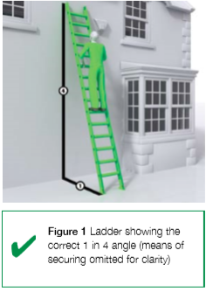
- Make sure the ladder angle is at 75° – you should use the 1 in 4 rule (i.e.1 unit out for every 4 units up)
- Always grip the ladder and face the ladder rungs while climbing or descending – don’t slide down the stiles;
- Don’t try to move or extend ladders while standing on the rungs;
- Don’t work off the top three rungs, and try to make sure the ladder extends at least 1 m (three rungs) above where you are working;
- Don’t stand ladders on moveable objects, such as pallets, bricks, lift trucks, tower scaffolds, excavator buckets, vans, or mobile elevating work platforms;
- Avoid holding items when climbing (consider using a tool belt);
- Don’t work within 6 m horizontally of any overhead power line, unless it has been made dead or it is protected with insulation. Use a non-conductive ladder (e.g. fibreglass or timber) for any electrical work;
- Maintain three points of contact when climbing (this means a hand and two feet) and wherever possible at the work position – see Figures 2 and 3;

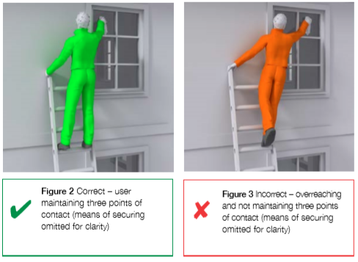
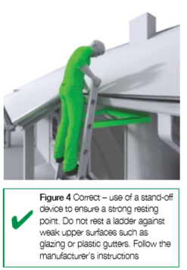
- Where you cannot maintain a handhold, other than for a brief period (e.g. to hold a nail while starting to knock it in, starting a screw etc.), you will need to take other measures to prevent a fall or reduce the consequences if one happened;

- For a leaning ladder, you should secure it (e.g. by tying the ladder to prevent it from slipping either outwards or sideways) and have a strong upper resting point, i.e. do not rest a ladder against weak upper surfaces (e.g. glazing or plastic gutters – see Figure 4);
- You could also use an effective stability device.

What are the options for securing ladders?
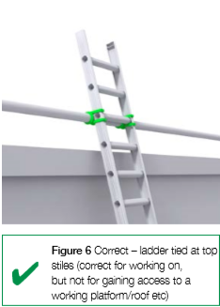
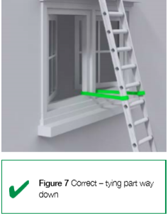
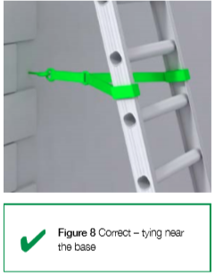
1. Tie the ladder to a suitable point, making sure both stiles are tied, see Figures 6, 7 and 8;

2. Where this is not practical, secure with an effective ladder stability device;
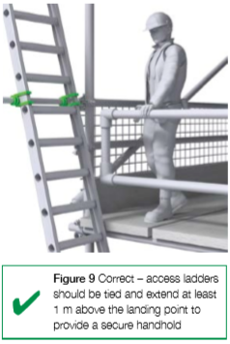
- If this is not possible, then securely wedge the ladder, e.g. wedge the stiles against a wall;
- If you can’t achieve any of these options, foot the ladder. Footing is the last resort. Avoid it, where ‘reasonably practicable’, by using other access equipment.

What about ladders used for access?
- Ladders used to access another level should be tied (see figure 9) and extend at least 1 m above the landing point to provide a secure handhold. At ladder access points, a self-closing gate is recommended;
- Stepladders should not be used to access another level, unless they have been specifically designed for this.
If any defects are noted DO NOT use the Ladder, remove it from use and report to supervisor
For further information:
- Please contact H&S team: healthandsafety@swansea.ac.uk
- INDG401 – Working at height guide. http://www.hse.gov.uk/pUbns/indg401.pdf
- INDG453 – Safe Use of Ladders. http://www.hse.gov.uk/pubns/indg455.htm
- Working at Height Regulations 2005. http://www.legislation.gov.uk/uksi/2005/735/contents/made

Questions

1. | Name 3 things you should consider when planning to work at height
2. | As a general rule, what is the maximum length of time a task should take if using a ladder
3. | When using a leaning ladder name 3 things you should consider or do when using.

Name______________________________________________________________________(Print & Sign)

Date____________________________

