Using OneDrive to Send Large Files

LOGGING INTO YOUR ONEDRIVE
Open your internet browser (Chrome/Firefox/Edge/etc.) and go to: https://myuni.swansea.ac.uk
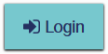
- Use your full email address to log into Microsoft. (The next time you log in this way, your account should be saved and you just need to click on your name). The password should be the one you use to log into your student account.

- From the drop-down menu, select “My Apps”
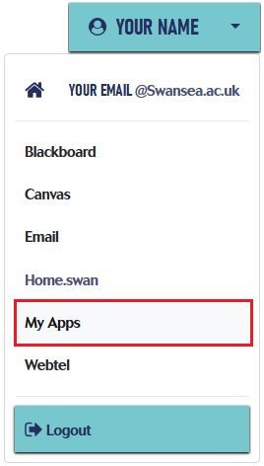

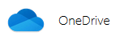
- From the list of “My Apps”, click on the OneDrive icon and open your OneDrive.

Once in your OneDrive, it’s recommended you create a folder where you can upload files specifically for sharing e.g. an “External Access” folder – this will keep them all together and you won’t need to search for files when they no longer need to be shared. Do the following within your new folder:

SHARING A FILE

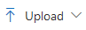
Once you have signed into OneDrive:
- Upload the file you want to share. This can be done with the “Upload” button
or by Dragging and Dropping the file into your screen.
- On the file you want to share, click the three dots next to the file/folder - it will appear when you hover over the file.
- Choose “Copy Link” from the menu. A pop-up screen will open:
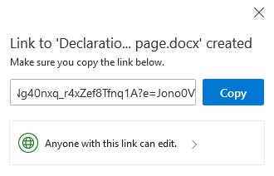
The standard settings will be that anyone can edit the file with the link. You can change these options **
- Copy the link and share it with your chosen recipient.

** CHANGING THE SHARING SETTING IN THE 365 SCREEN

The standard setting for sharing a file through OneDrive is that anyone with the link can share the link for as long as the file is one your OneDrive (i.e. the link is valid).
You have other options when sharing the link from the 365 screen:
- Click on “Anyone with this link can edit”, situated under the link:

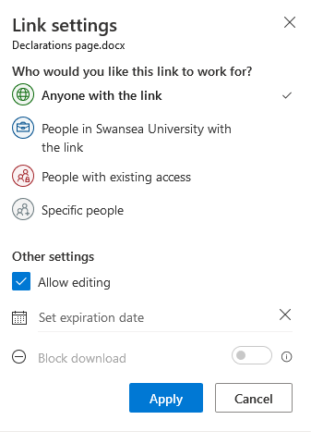
You can choose who can use the link, making in only available for:
- Anyone with the link
- Swansea University staff members.
- People with existing access to your OneDrive.
- Specific people (here you enter their email addresses / 365 login emails).

You can also choose:
- If you allow people with the link to edit your document
- When the link will expire
- If you only want to let the people with the link to see it online and not download the file.

