SOP-10100 Standard Operating Procedure for the Use of Class II Microbiological Safety Cabinets
Introduction: Class II Microbiological Safety Cabinets (MSCs) are designed to protect users from biological hazards. Air is drawn in through the front of the cabinet and is directed below the main working platform of the cabinet via special baffles and perforations in the front lip of the cabinet. This inflow of air through the front prevents the escape (contains) the agents in use. The air is passed through a HEPA filter and forms a sterile curtain (down flow) of air from the ceiling of the cabinet, protecting the samples from airborne contamination.

In most European designs about 70-80% of the air is recirculated within the cabinet (as the down flow of “sterile” air). 20-30% of the air is discharged, either directly outside (ducted) or back into the laboratory. Some cabinets are fitted with multiple in-line HEPA filters as an additional precaution against filter penetration.
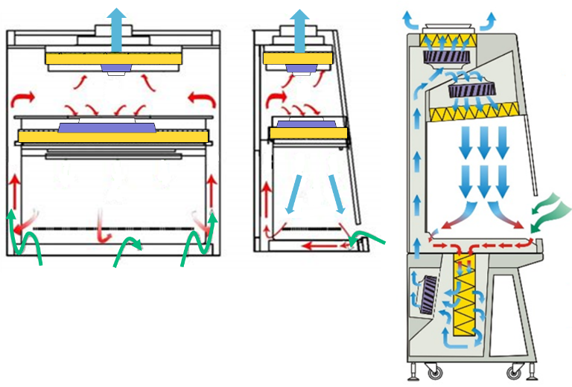
HEPA filter
Fans
Contaminated air
Room air
Clean (filtered) air

These cabinets are suitable for work with hazard group 2 biological agents, human or animal samples and cell cultures. Harmful chemicals which are volatile (give off vapour) should not be used in these cabinets as they will not be captured in the High Efficiency Particulate Air Filter (HEPA), and will recirculate in the cabinet. For non-ducted cabinets these chemicals will be exhausted into the laboratory.

Pre-use checks
- Ensure the cabinet is the correct type for the activity.
- Check that the cabinet has a test sticker confirming that it has been thoroughly examined and tested within the last 14 months (and has passed the test). Do not use the cabinet if it is outside the 14-month test period. Contact the lab supervisor.
- Before using a cabinet, the night door should be opened, fans switched on and allowed to stabilize for 5 minutes.
- Check the cabinet air-flow is within the safe-range, the average face velocity should read above 0.4 m/s - do not use the cabinet if it is not working properly.
- Ensure there is sufficient space to conduct the work safely. Equipment in the cabinet should be kept to a minimum and sited at least 15 cm inside the plane of the sash to ensure efficient containment.
- Items should not obstruct the opening of the cabinet as this may disrupt the protective inward air-flow. The rear baffle should also not be obstructed.
- Avoid placing large pieces of equipment in the cabinet where possible, as they may reduce the effectiveness of the containment. If their use cannot be avoided they should be raised up about 10cm using lab jacks, in order to allow air to pass unimpeded across the work surface.
- Clean down surfaces and equipment being brought in with an appropriate disinfectant.
During use
- Keep the work area clean and tidy.
- Perform operations as close to the middle of the cabinet as possible.
- Avoid swift arm and body movements in front of the cabinet, they can cause turbulence that may draw the airborne hazardous material out of the front of the cabinet.
- Cabinets are designed for single users only – multiple bodies in front of the cabinet can affect containment. If another person is observing work, ensure they stand a little away (e.g. >30 cm) from the cabinet opening.
- Do not use naked flames (including Bunsen burners) as they will have a serious adverse effect on the air flow.
- Hotplates must be kept to a minimum and be aware that they might adversely affect the airflow. If hot plates are used, these should be placed at least 10 cm from the side and back of the MSC to avoid damage to the MSC structure.
After use
- Remove all waste and materials from the cabinet, disinfect equipment with a suitable disinfectant.
- All parts of the working area of the cabinet should then be swabbed with a suitable disinfectant (as recommended by the cabinet manufacturer).
- Note that although swabbing with 70% Ethanol is often used for this it may presents a serious risk of fire if there are any naked flames or sources of ignition in or near the cabinet.
- The cabinet should be run for at least 5 minutes after use to assist the removal of residual contaminated aerosols.
- Switch off the cabinet and shut the night door.
- The UV lamp, if fitted, should never be on while the cabinet is in use or when other users are in the facility.
Emergencies
- If the alarm sounds during work make the work secure e.g. seal tubes.
- If the cabinet air flow fails during use, if safe to do so seal the front with the night door, switch off and clearly label and contact the lab supervisor.
- Deal with spillages immediately, using the appropriate disinfectant and/ or correct absorption materials.

Document Control
Document Name | Standard Operating Procedure for the Use of Microbiological Safety Cabinets
Document Ref. Number | SOP-10100
Revision | 2.0
Date of Issue | May 2021
Written By | Gretta Roberts
Amended by | Andy Lee
Reviewed by | Biological Hazard and GMO Sub-Committee
Contact Email | healthandsafety@swansea.ac.uk

Amendment Record
Revision | Date | Amendment(s)
0 |  | Draft
1 | July 18 | New SOP
2 | May 21 | Minor Review

