INFORMATION SHEET
Risk Assessment

Definitions and Objectives
- What is a risk assessment?
A systematic method of identifying:
- The hazards and risks present in an activity;
- How things can go wrong and who might be hurt;
- The controls required to reduce the risk to an acceptable level.

- What are the objectives of risk assessment?
- To prevent death and personal injury;
- To improve health and wellbeing outcomes;
- To comply with the law;
- To save money;
- To support sensible risk management.

- Hazard and Risk: What is the difference?
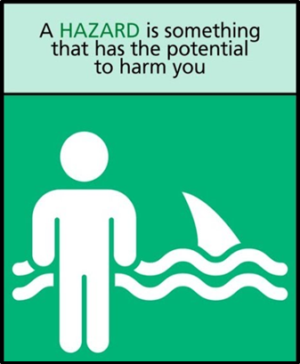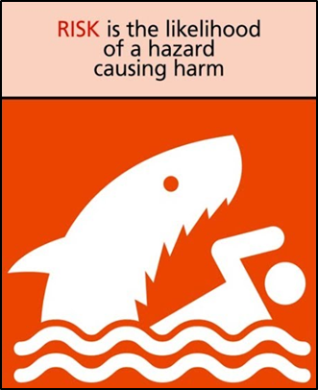

Risk Assessment Process: 5 Steps
- Identifying the hazards
Step 1

To identify the hazards you will need to consider:
- Location;
- Activities;
- Task observation;

- Equipment and substances;
- Consultation with colleagues or industry expert;
- Legal standards, relevant regulation and approved codes of practice;
- Guidance and benchmarking;
- Manuals, chemical labels, MSDS;
- Accident, ill health or near miss data;
- Workplace inspection reports.

- Identify the people who/ what might be harmed and how
Step 2

- Students;
- Employees;
- Maintenance staff;
- Cleaners;
- Contractors;
- Visitors;
- Members of the public (incl. trespassers).
Remember to consider people at additional risk:
- New or expectant mothers;
- People with a disability;
- Lone workers;
- Young people.

- Evaluate the risk and decide on controls
Step 3

- Determine whether existing control measures are in place and effective;
- Are any additional control measures required?
You can either use a matrix, like the one in Appendix 1, to help evaluate risk and decide on control measures or just consider what controls would be suitable and sufficient for the task. Either approach is acceptable.

Remember the hierarchy of control for helping you determine what controls to put in place (Figure 1).

Figure 1: Hierarchy of control
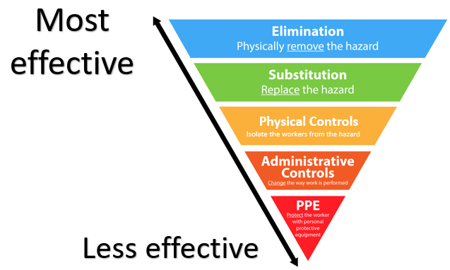

- Record the significant findings and implement
Step 4

You need to record:
- Location, equipment and activity being assessed;
- Date and time of the assessment and date for review;
- Significant hazards;
- People affected;
- Existing controls;
- Further actions/ controls required;
- Cross-reference to any other documents (e.g. work policies/ procedures/ risk assessment/ permits);
- Ensure this record is readily available.

- Review and update as necessary
Step 5

Significant change | Validity | Periodically
- Process  - Substance  - Equipment  - Work place environment  - Personnel | - Adverse event  - Ill health  - Change to legal standards | - For example: Annually
Step 5

Significant change | Validity | Periodically
- Process  - Substance  - Equipment  - Work place environment  - Personnel | - Adverse event  - Ill health  - Change to legal standards | - For example: Annually

Dynamic Risk Assessment
A Dynamic Risk Assessment is the practice of mentally observing, assessing and analysing an environment while at work, to identify and reduce risk. The process allows individuals to identify a hazard on the spot and make quick decisions in regards to their own safety.

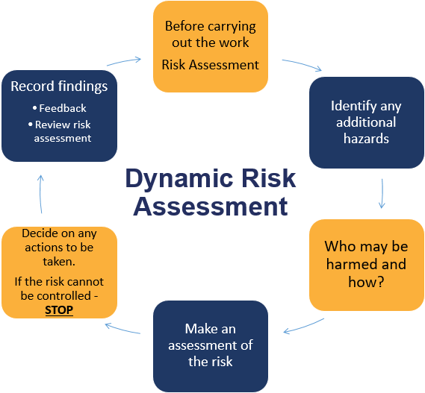

Appendix 1: Risk Assessment Matrix

