Introducing Open Timetables
Open Timetables provides greater visibility of the timetable, allowing users to find and view the timetable of an element of the academic structure (for example, a programme of study) or a resource (for example, a particular location). Open Timetables shows the user all that item's activities on one timetable.
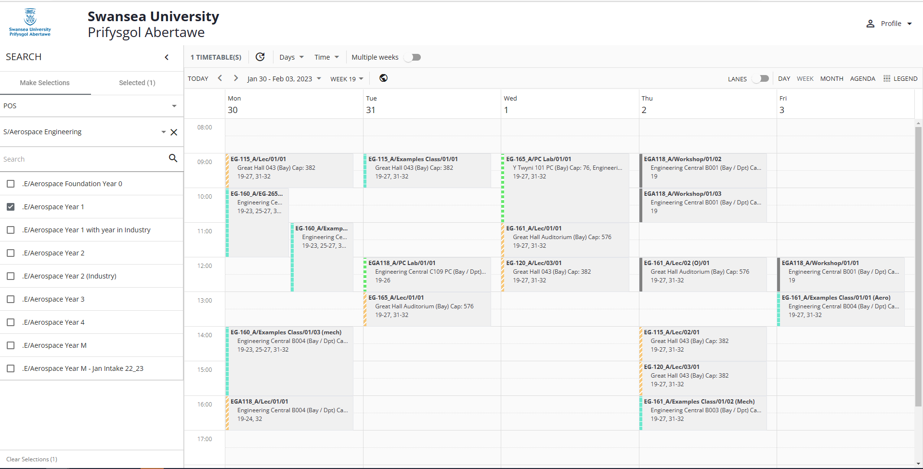

Timetable views
Timetables can be presented in several views. The user chooses the view that they want to use:
- Day / Week / Month

- Agenda: Presents activities in a list format
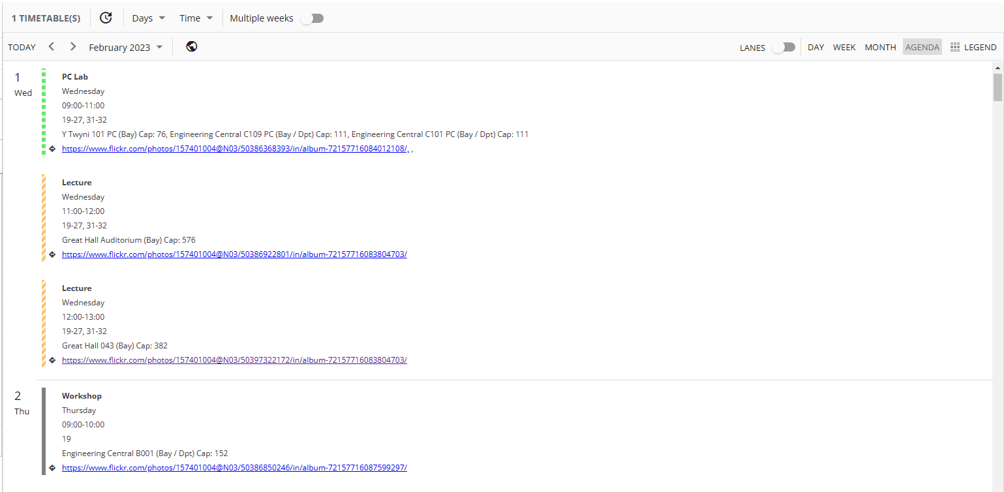

- Lanes: Presents activities in a timeline format, in which each selected item gets its own row, with each item's activities appearing within its row. This view can help the user to compare resources.
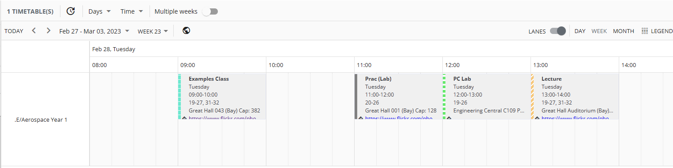

The User Interface
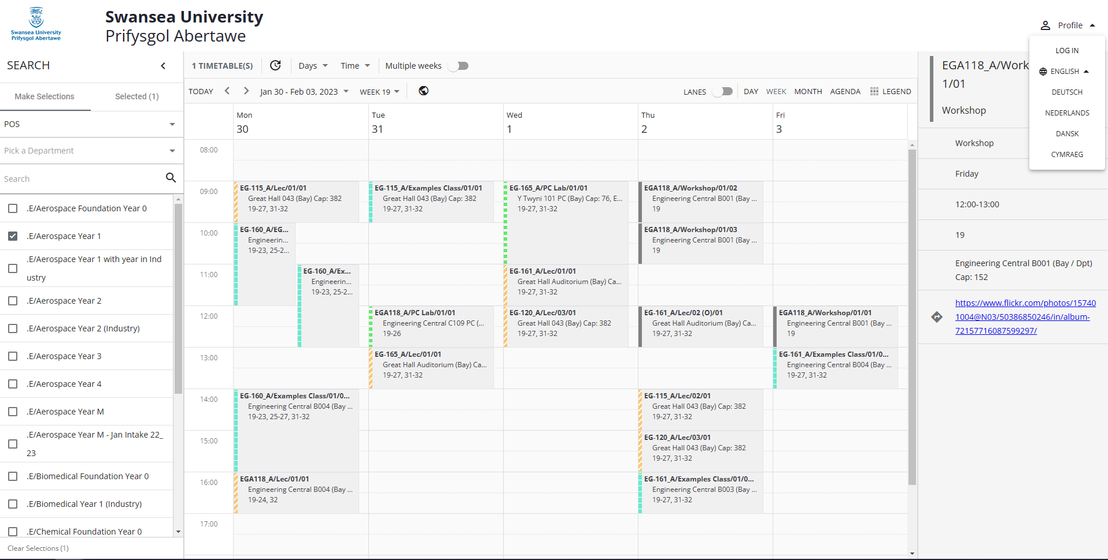
1
5
2
4
6
3
Number | Element | Description
1 | Search area | Use these tools to find items. Timetables can be viewed by POS (Programme of Study), Module or Location
2 | Search results | To see an item's timetable, choose it here. To bring the timetable of multiple items together onto the same timetable view, the user can select multiple items here
3 | Search results | The timetable of the selected items
4 | View options | The user can choose which times, days, and weeks that they want to view timetable information for. If the user selects more than one week, the timetable combines all selected weeks' activities
5 | Activity details area | If the user clicks an activity, its details appear
6 | Language selector | Switch Open Timetables to a different language

Date range and time range
Users can choose which weeks, days, and times are included in the timetable. So, for example, you can choose to see only next week's timetable.
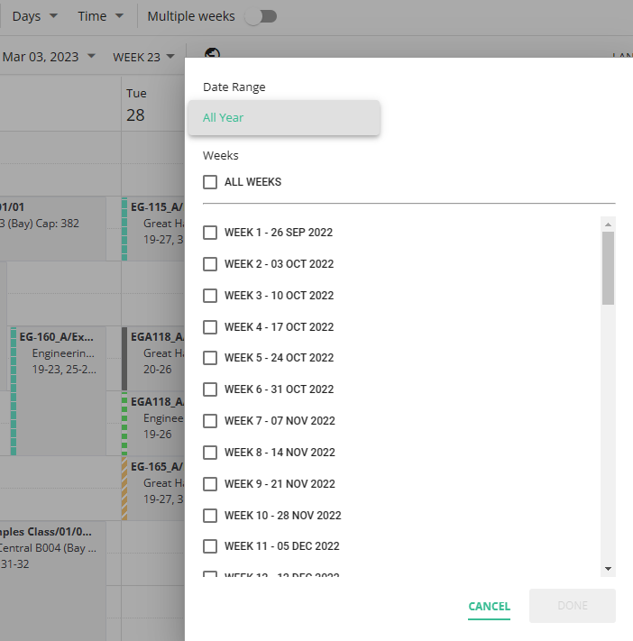

Further Filtering Options via the Legend Icon:
You are also able to filter further via the Legend icon on the top right of the timetable. Here in the drop-down menu, you can view just lectures or seminars for example.

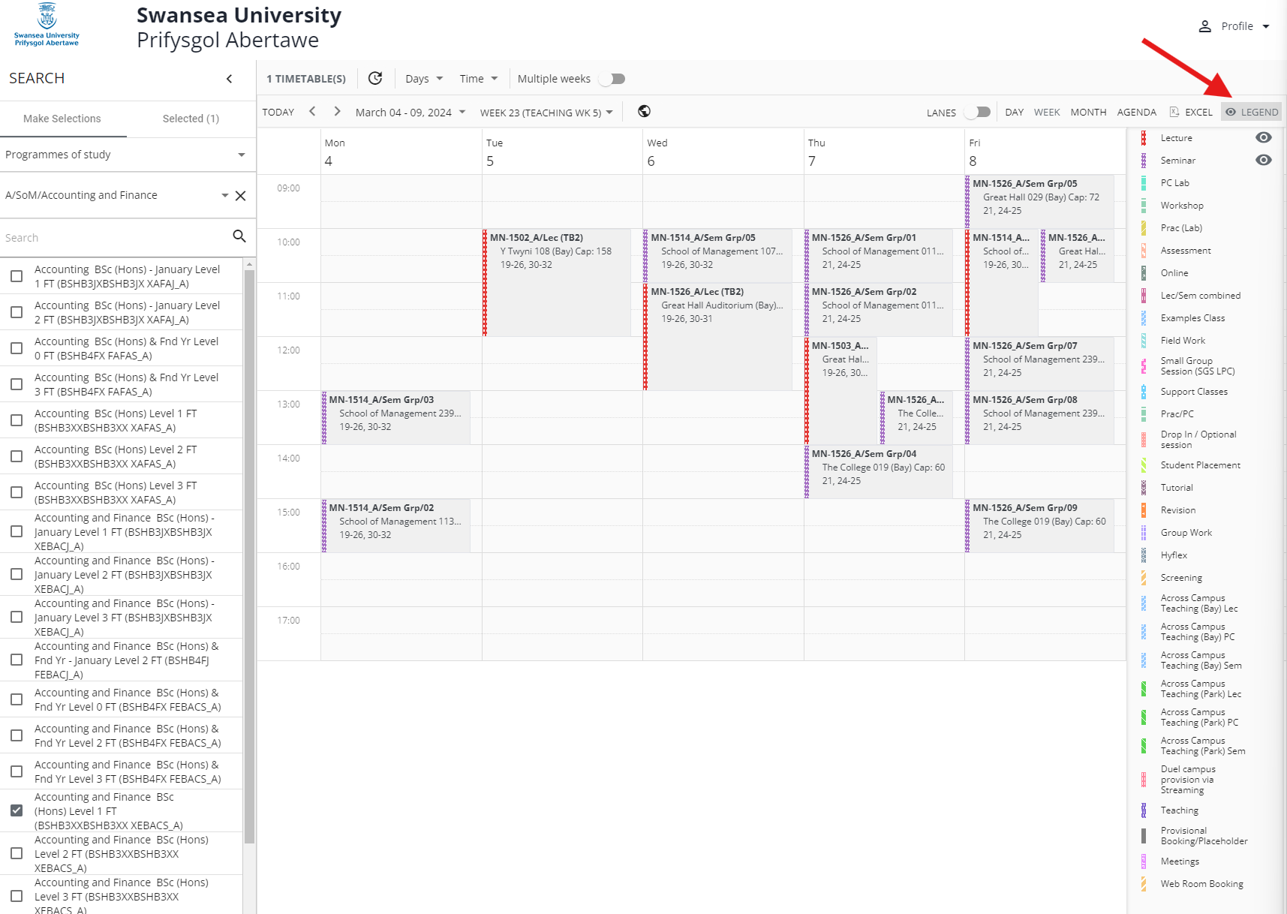

Exporting the Timetable Information to an EXCEL Spreadsheet.
You can export the timetable information that you are viewing into an EXCEL Spreadsheet.

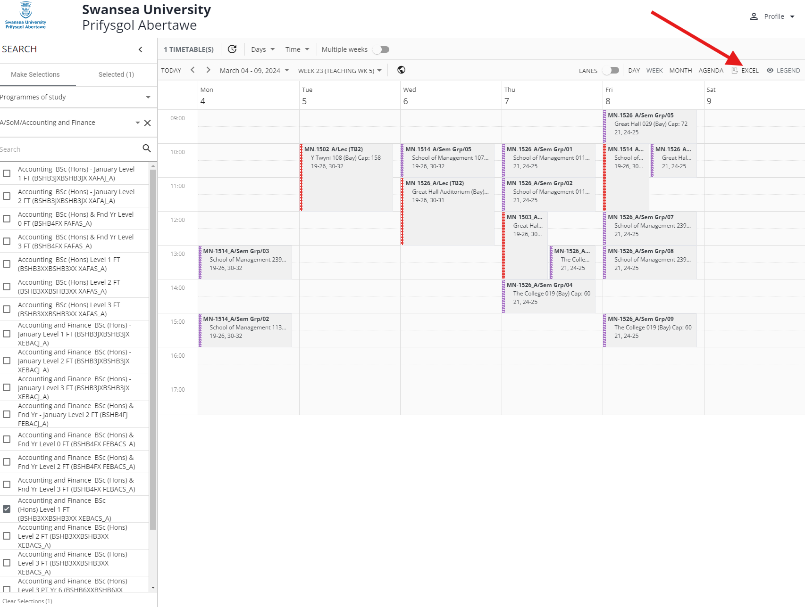
Once you click on the EXCEL Icon it will download a spreadsheet of what you are currently viewing

