INFORMATION SHEET
Manual Handling in libraries
This information sheet is to provide guidance for all colleagues working in the library. The manual handling risks are identified and explained. All employees should read and adhere to the guidance detailed in this for.
Library tasks can be broken down into 3 main sections:

1. Issue and return
The issuing desk is positioned in the main foyer of the library and books can be either issued or returned via the desk or self-issue terminals and book return.
- When possible slide books across the desk, ensure you are not bending or twisting whilst in the sitting position to place books on trolley
- Task can be repetitive and the tasks should be rotated

Returning Books
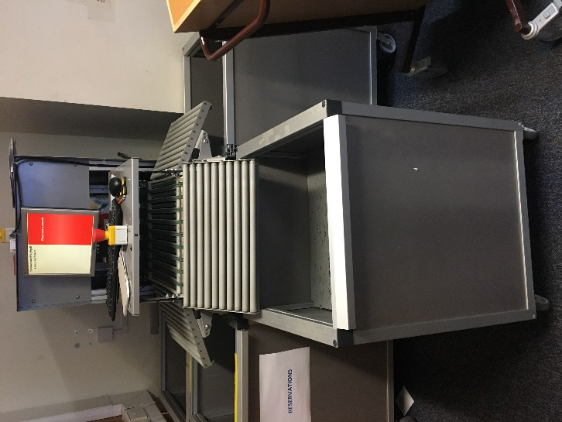
Books are returned through the automated system that allocates books into a specific bin with a spring loaded base depending on the floor they are stored.
- When removing books, you should be standing square on to the bin, once the book has been lifted and assessed for damage you should move your feet rather than twist to place the book on the designated trolley.
- If books become jammed between the base of the bin and the top, you should ask another colleague for assistance, one to press down the base to release the book and another to retrieve the book.

2. Re-shelving
- Familiarise yourself with the work area
- When inserting books you normally use dominant hand, the hold should be tight pinch grip on the spine, and supported underneath where applicable.
- Vary the use of muscles as you work, try to swap tasks if possible or at least swap hands from time to time to reduce stress and rest if tired.
- Books should be rested on shelves before being slid into place
- Loads can be heavy, large or awkward and may require 2 hands to lift and place on shelf. Colleagues should maintain good manual handling positioning where possible

- If shelves are tightly packed do not push the books by hand
- Moving book ends and dividers should not be moved one handed
- If moving more than one book at a time don’t over stretch hand span
- When removing books pull out one at a time and support underneath with the other hand
- Don’t try to force a book into a space
- Heavy books should be transported at waist height
- Ensure you are not carrying too many books at once or hold stack of books in non-dominant arm.
- Twisting, excessive reaching forward, reaching above head height or below the knee should be avoided where possible
- Kick stools are provided to allow shelves to be reached safely without having to lift books above shoulder height
- Hold books as close to body as possible, avoid reaching to far below knee height and sit on kick stool or floor
- Kick stools can be a trip hazards and should be stored correctly
- When using a trolley keep it close but don’t stretch across it
- Be aware of shelf supports if one has become loose report it immediately and ensure help is obtained before removing books.

Shelving at height
- Avoid twisting your body as you lift , try to maintain good posture i.e. straight back
- Where practicable work should be varied or alternated.
3. Trollies
- In the library there are 2 kind of trollies

Wooden Trollies – these have 2 shelves either side of the trolley. 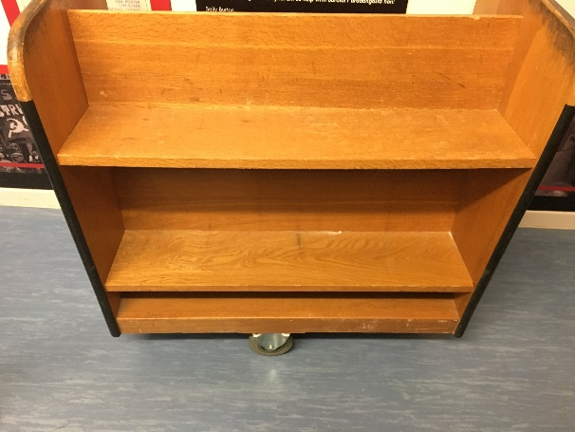
Red trollies – these have 3 single shelves, the bottom shelf is not used
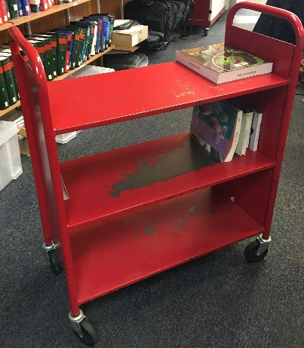
- Trollies should be inspected prior loading to ensure all shelves are secure, the trolley moves freely and is easy to manoeuvre. If the trolley fails the inspection it should be removed from service immediately and either repaired or disposed of through the appropriate route.
- Place books upright on the trolley
- When loading the trolley ensure it is not top heavy or overloaded on one side; never balance books on top of others
- Ensure trollies are no overloaded

- Ensure books on lower shelves are not sticking out
- If you cannot move a trolley by yourself, ask for assistance or remove some of the load prior to moving trolley.
- Find the best route involving the least manoeuvres and changes of level
- Make sure you have a good grip on the trolley handles
- Push the trolley rather than pull it; lean in the direction you are pushing; stay close to the trolley and move the trolley using your body weight and leg muscles.
- If working as a pair, the front person carefully walks backwards; colleagues should swap ends from time to time if going a long distance
- Remain vigilant and keep a look out for obstructions and /or people coming the other way
- Keep your hands away from the edges when going through doorways and down aisles; ask a colleague to hold doors open for you
- If the load starts to shift, stop and readjust it
- Move the trolley as close as practicable to the shelves you are using, but don’t stretch across it.

Name_______________________________________________________________(Print & Sign)

Date_______________________________________________________________________

