INFORMATION SHEET
Manual Handling

What is Manual Handling?
The Regulations define manual handling as: Any transporting or supporting of a load including lifting, carrying, pushing, pulling or putting down by hand or bodily force.

Poor manual handling technique can result in personal injury
In reality most jobs involve some manual handling. The risks can be assessed by focussing on the following areas.
Task – What is involved?
Individual – work within your own capabilities. Remember everyone is different
Load – Assess the load is it, unstable?
Environment – lighting, flooring etc.

How can you minimise the risks?
1. Use mechanical aids where possible  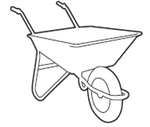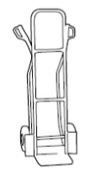 | - Using a trolley, sack truck or wheel barrow etc. is much easier
2. Good Lifting technique  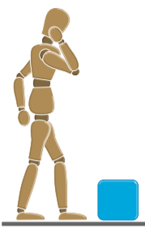  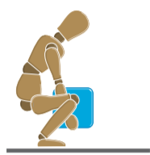  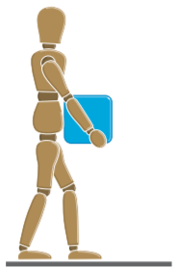  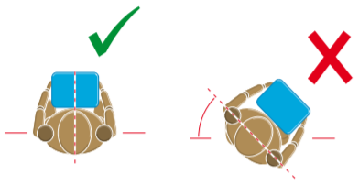  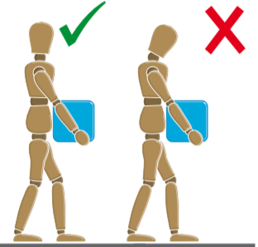  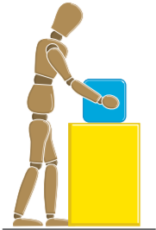 | Before Lifting  - Plan the lift. Can handling aids be used?  - Where is the load going to be placed?  - Will help be needed with the load?  - Remove obstructions such as discarded wrapping materials.  - For a long lift, consider resting the load midway on a table or bench to change grip.  The Lift  - Adopt a stable position. The feet should be apart with one leg slightly forward to maintain balance (alongside the load, if it is on the ground). Be prepared to move your feet during the lift to maintain your stability. Avoid tight clothing or unsuitable footwear, which may make this difficult.  - Get a good hold. Where possible, the load should be hugged as close as possible to the body. This may be better than gripping it tightly with hands only.  - Start in a good posture. At the start of the lift, slight bending of the back, hips and knees is preferable to fully flexing the back (stooping) or fully flexing the hips and knees (squatting).  - Don’t flex the back any further while lifting. This can happen if the legs begin to straighten before starting to raise the load.  - Keep the load close to the waist. Keep the load close to the body for as long as possible while lifting. Keep the heaviest side of the  Load next to the body. If a close approach to the load is not possible, try to slide it towards the body before attempting to lift it.  - Avoid twisting the back or leaning sideways, especially while the back is bent. Shoulders should be kept level and facing in the same direction as the hips. Turning by moving the feet is better than twisting and lifting at the same time.  - Keep the head up when handling. Look ahead, not down at the load, once it has been held securely.  - Move smoothly. The load should not be jerked or snatched as this can make it harder to keep control and can increase the risk of injury.  - Don’t lift or handle more than can be easily managed. There is a difference between what people can lift and what they can safely lift. If in doubt, seek advice or get help.  - Put down, then adjust. If precise positioning of the load is necessary, put it down first, then slide it into the desired position.  Setting Down  - Use the same principles as the lifting  - Maintain good balance  - Set the load down and then adjust its position using body weight.
3. Wear suitable clothing | - Tight fitting clothing or unsuitable footwear can hinder you lift
4. Know you limits | - If it is too heavy to lift on your own STOP and seek assistance
5. Push rather than pull  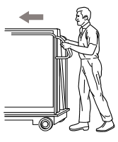 | - Check equipment prior to use to ensure it is working correctly.  - Handle height should be between shoulder and waist height  - Check the route, ensure any obstacles are cleared. If a slope or ramp cannot be avoided request adequate assistance to navigate.  - If terrain changes the force required may be greater, ensure there are places to rest if necessary  - Push rather than pull where possible, remember to make sure you can see over the top  - Keep feet away from the load and move no faster than walking speed.
6. Move your feet | - Avoid twisting or leaning because this places pressure on your spine. When you turn you should move your feet.
7. Team Work  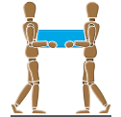 | - If working as a team remember communication is key. Instructions should be clear and concise

Questions
1. | What does TILE stand for?
2. | Name 3 ways to reduce risk from manual handing?
3. | Why should you move your feet?

Name_________________________________________________________(Print &Sign)

Date_________________________________________________________________

