Y Gyfadran Gwyddoniaeth a Pheirianneg

Arweiniad i fyfyrwyr ynghylch sut i gwblhau cais
i drosglwyddo i gwrs arall

Gallwch chi ddefnyddio'r arweiniad hwn i weld y camau y mae angen i chi eu cymryd wrth gyflwyno cais i drosglwyddo i gwrs arall.

Cysylltwch â'r Tîm Profiad a Gwybodaeth Myfyrwyr os oes gennych chi gwestiynau neu os oes angen cymorth arnoch chi gyda'ch cais.

Cam 1: Mewngofnodwch i https://fse-intranet.swan.ac.uk/

Cam 2: Cliciwch ar Myfyrwyr yn Trosglwyddo

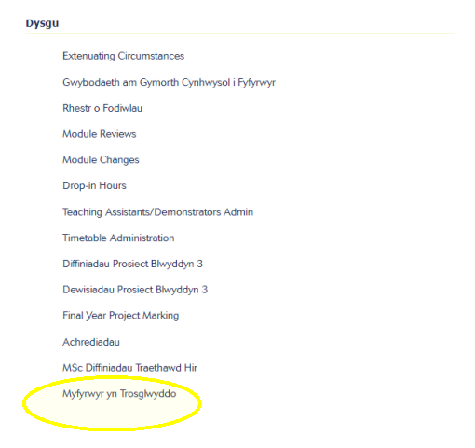

Cam 3: Darllenwch yr arweiniad
Gallwch chi ddod o hyd i ddolen i'r arweiniad llawn yn yr adran gyntaf, ‘Trosglwyddo i Gwrs Arall’. Darllenwch hwn yn llawn cyn dechrau ar eich cais. Gallwch chi hefyd gael mynediad at yr arweiniad hwn ar ein tudalennau gwe yma.

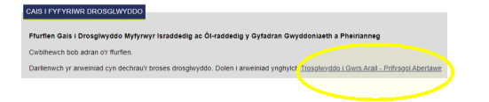

Cam 4: Cadarnhewch fanylion eich cwrs presennol
Bydd cofnod yn ymddangos fel y gallwch chi lenwi manylion eich cwrs presennol.

Nodwch eich ‘Dyddiad Presenoldeb Diwethaf’. Caiff y ‘Dyddiad Gorffen Disgwyliedig’ ei lenwi'n awtomatig.

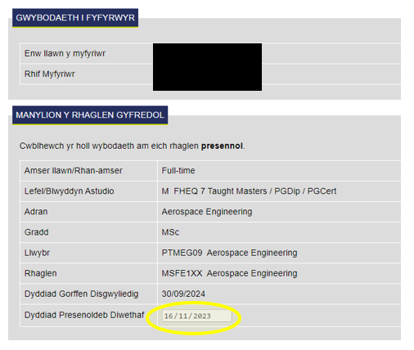

Cam 5: Nodwch fanylion eich rhaglen newydd

Dewiswch o'r gwymplen drwy glicio ar y saeth ar gyfer y meysydd canlynol:

- Adran: dyma adran y rhaglen newydd rydych chi am drosglwyddo iddi.
- Modd Presenoldeb: er enghraifft, amser llawn neu ran-amser.
- Gradd: er enghraifft, BSc, BEng, MEng.
- Rhaglen: byddwch chi'n gallu dewis teitl y rhaglen.
- Blwyddyn Astudio: dewiswch eich blwyddyn astudio ar y rhaglen newydd (e.e. Blwyddyn 1, 2, 3).
- Dyddiad Cychwyn ar y Rhaglen Newydd: gan y bydd eich astudiaethau'n barhaus, bydd hyn fel arfer yn dechrau o ddyddiad gorffen eich rhaglen flaenorol.
- Dyddiad Gorffen Disgwyliedig Newydd: dyma'r flwyddyn pan fyddwch chi'n graddio. Fel arfer, bydd cyrsiau israddedig yn gorffen ym mis Mehefin. Bydd cyrsiau ôl-raddedig a addysgir sy’n dechrau ym mis Medi yn gorffen ar 30 Medi a bydd y rhai sy’n dechrau ym mis Ionawr yn gorffen ar 26 Ionawr.

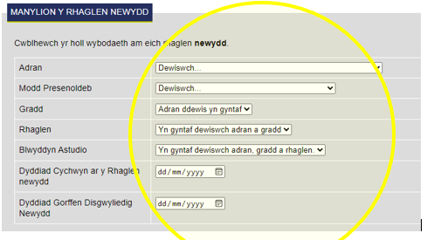

Cam 6: Rheswm dros y Cais i Drosglwyddo

Nodwch eich rheswm dros drosglwyddo. Bydd brawddeg fer yn ddigon, er enghraifft, ‘Hoffwn i gwblhau Blwyddyn mewn Diwydiant’.

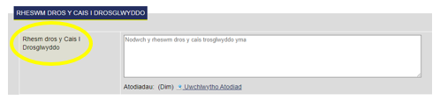

Bydd yn rhaid i chi hefyd lanlwytho dogfennau:

- Os byddwch chi yn trosglwyddo i adran arall. Bydd angen i chi lanlwytho e-bost sy'n cadarnhau cymeradwyaeth academaidd gan y Tiwtor Derbyn Myfyrwyr yn eich adran newydd.
- Os ydych chi ar fisa Llwybr Myfyrwyr. Lanlwythwch Holiadur Astudiaethau Blaenorol wedi'i gwblhau.

Cliciwch ar ‘Uwchlwytho Atodiad’ a dewiswch y ffeil o'ch cyfrifiadur/dyfais.

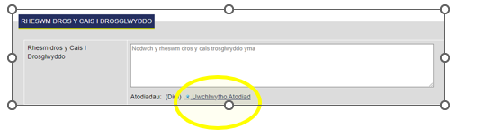

I lanlwytho atodiad, gallwch chi glicio ar ‘Uwchlwytho ffeil’, dod o hyd i'r ffeil ar eich cyfrifiadur/dyfais a chlicio ar ‘Ychwanegu’.

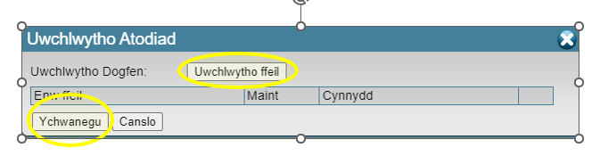

Nodyn Pwysig: Os ydych chi'n trosglwyddo i adran arall ac nad ydych chi wedi lanlwytho'r gymeradwyaeth academaidd gan y Tiwtor Derbyn Myfyrwyr, ni fyddwch chi'n gallu cyflwyno eich cais.

Cam 7: Modiwlau i'w diwygio

Nodwch y modiwlau y byddech chi'n eu hastudio ar y rhaglen newydd a modiwlau eich rhaglen bresennol na fyddech chi'n eu hastudio mwyach.

A wnewch chi gwblhau hyn ochr yn ochr â'r modiwlau a ddewiswyd gennych chi eisoes yn eich Proffil MyUni. Ar ôl mewngofnodi, cliciwch ar ‘Proffil’ a ‘Cyrsiau’.

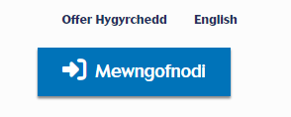

Mae’r rhestr o fodiwlau’r rhaglen newydd yn deillio o gatalogau cyrsiau'r Brifysgol, sydd ar gael drwy'r dolenni isod:

- Catalog Cyrsiau Israddedig
- Catalog Cyrsiau Ôl-raddedig a Addysgir

A wnewch chi glicio ar eich cwrs newydd, sgrolio i lawr i ‘Modiwlau’ ac agor y flwyddyn berthnasol.

Dewiswch o'r gwymplen pa fodiwl(au) rydych chi am eu gollwng a pha fodiwl(au) rydych chi am ddechrau arnyn nhw.

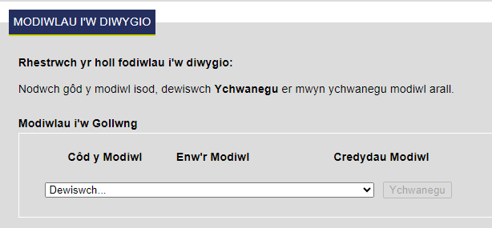

Dyma enghraifft o sut olwg fyddai ar y rhan hon pan gaiff ei llenwi:

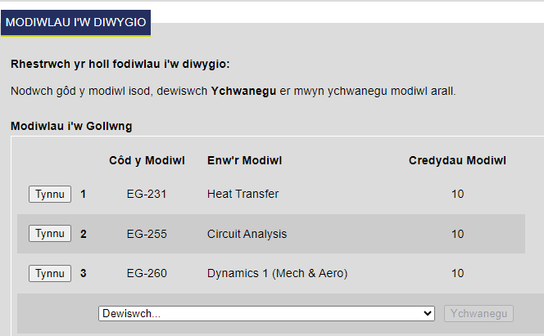

Os nad oes gennych chi eich dogfen(nau) ategol eto, gellir lanlwytho’r rhain yn nes ymlaen, ond rhaid eu darparu o fewn mis i ddyddiad eich cais.

Cam 8: Cadw a Chyflwyno

Gallwch chi bellach gyflwyno eich cais drwy glicio ar ‘CYFLWYNO’.

Os byddwch chi am ddychwelyd i'r cais, gallwch chi glicio ar ‘CADW’.

Sylwer: Ni fydd eich cais yn cael ei adolygu os na fyddwch chi'n clicio ar ‘CYFLWYNO’.

Beth sy’n digwydd nesaf:

- Cam 1: Byddwch chi'n derbyn e-bost cadarnhau i roi gwybod i chi fod eich cais i drosglwyddo i gwrs arall yn cael ei adolygu gan y Tîm Profiad a Gwybodaeth Myfyrwyr yn y Gyfadran Gwyddoniaeth a Pheirianneg.

- Cam 2: Ar ôl i'r adolygiad hwn gael ei gynnal, byddwch chi'n derbyn e-bost arall i roi gwybod i chi ei fod wedi cael ei anfon i'r Brifysgol at ddibenion cymeradwyo.

- Cam 3: Pan fydd eich trosglwyddiad wedi cael ei gadarnhau gan y Brifysgol, byddwch chi'n derbyn e-bost cadarnhau terfynol i roi gwybod i chi fod eich Cofnod Myfyriwr wedi cael ei ddiwygio i adlewyrchu'r newid yn eich rhaglen.

Rydyn ni'n gobeithio y bydd yr arweiniad hwn yn ddefnyddiol i chi. Os oes gennych gwestiynau neu adborth, mae croeso i chi e-bostio'r Tîm Gwybodaeth a Phrofiad Myfyrwyr yn StudentSupport-ScienceEngineering@abertawe.ac.uk

Faculty of Science and Engineering

Student Guide about How to Complete a
Course Transfer Request

You can use this guide to see the steps you need to take when requesting to transfer your course.

Please contact the Student Experience and Information Team if you have any questions or if you need support with your request.

Step 1: Log in to https://fse-intranet.swan.ac.uk/

Step 2: Click on Student Transfers

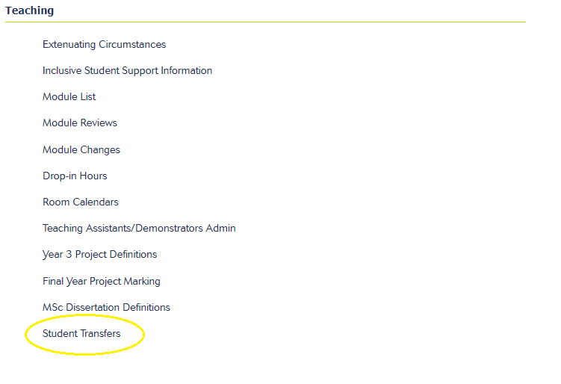

Step 3: Read Guidance
You can find a link to full guidance in the first section, ‘Request for Student Transfer’. Please read this in full prior to commencing your application. You can also access this guidance on our webpages here.

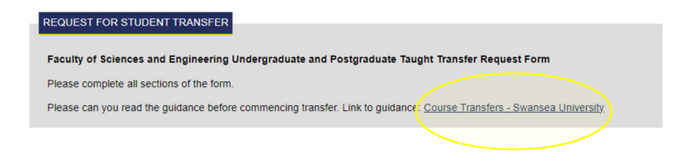

Step 4: Confirm Current Course Details
A record will appear for you to complete your current course details.

Please enter your ‘Date of Last Attendance’. The ‘Expected End Date’ will be automatically completed.

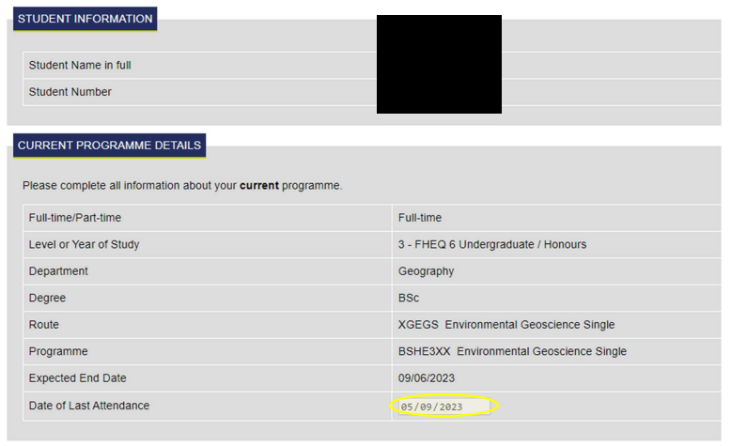

Step 5: Enter new Programme Details

Select from the drop down menu by clicking the drop down arrow for the following fields:

- Department: this is the Department of the new programme that you are requesting to transfer to.
- Mode of Attendance: for example, full time or part time.
- Degree: for example, BSc, BEng, MEng etc.
- Programme: you will be able to select the Title of the Programme.
- Year of Study: please select the year of study you will be entering into on the new programme (e.g. Year 1, 2, 3 etc.).
- New Start Date on New Programme: as study is continuous normally this runs from the end date of your previous programme.
- New Expected End Date: this is the year you will be graduating. Normally Undergraduate courses will end in June. Postgraduate Taught courses for September entry students will end on 30th September and for January entry students on 26th January.

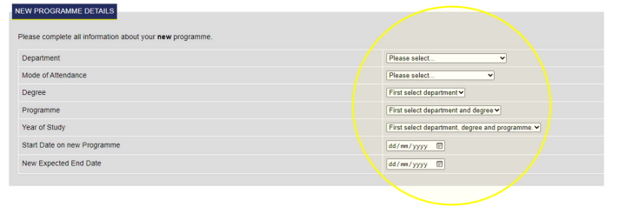

Step 6: Reason for Transfer Request

Please enter the reason for your transfer. Only a short sentence is sufficient, for example, ‘I would like to complete a Year in Industry’.

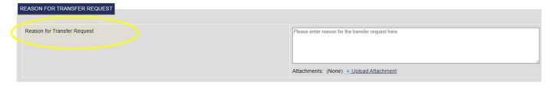

You will be required to also upload attachments if:

- You are switching between departments. You will need to upload an email confirming academic approval from the Admissions Tutor for your new department.
- You are on a Student Route Visa. Please upload a completed Previous Study Questionnaire.

Click on ‘Upload Attachment’ and select the file from your computer/device.

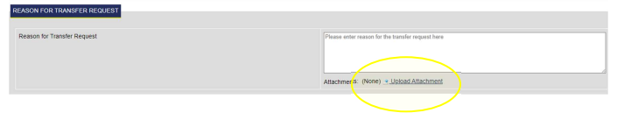

To upload an attachment you can click ‘Upload a file’, find the file on your computer/device and click ‘Add’.

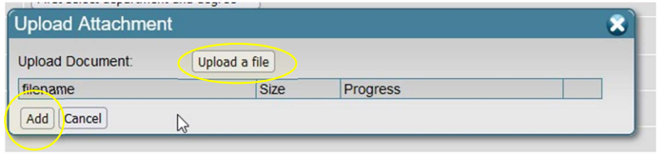

Important Note: If you are transferring to another department and have not uploaded the academic approval from the Admissions Tutor then you will not be able to submit your application.

Step 7: Modules to be Amended

Enter the Modules which you would be taking on the new programme and the Modules which you would no longer be taking from your current programme.

Please complete in conjunction with your module selections which you have already selected on your MyUni Profile. After logging in please click on ‘Profile’ and ‘Courses’.

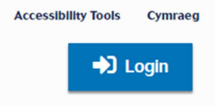

The Module listings for the new programme are from the University Course Catalogues which can be accessed below:

- Undergraduate Course Catalogue
- Postgraduate Taught Course Catalogue

Please click on your new course, scroll down to ‘Modules’ and open the relevant ‘Year’.

Select from the drop down which module(s) you wish to drop and which module(s) you wish to pick up.

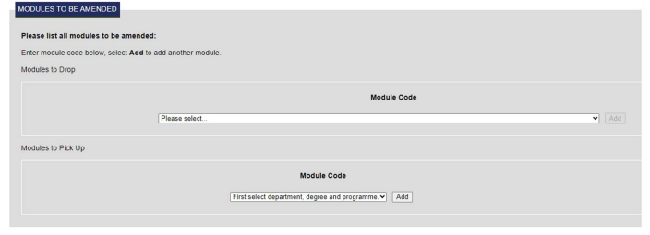

Here is an example of what this section would look like when populated:

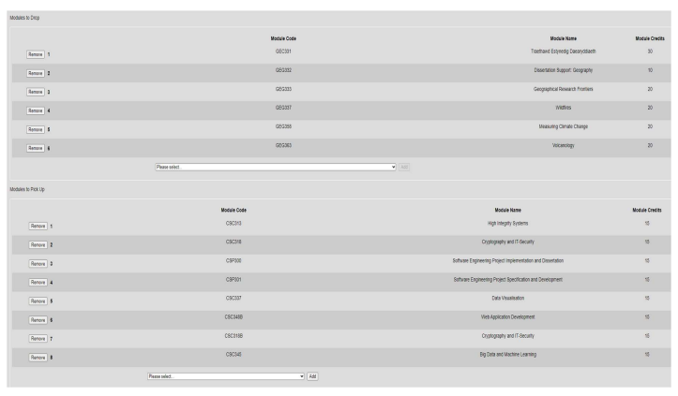

If you do nothave your supporting document/s yet, these can be uploaded later, but must beprovided within one month of the date of your request.

Step 8: Save and Submit

You are now able to submit your application by pressing ‘SUBMIT’.

If you wish to come back to the application you can choose to press ‘SAVE’.

Please Note: Your application will only be submitted for review if you press ‘SUBMIT’.

What Happens Next:

- Stage 1: You will receive a confirmation email advising you that your transfer request is being reviewed by the Student Experience and Information Team within the Faculty of Science and Engineering.

- Stage 2: When this review has taken place you will receive a further email advising you that it has been sent to the University for approval.

- Stage 3: When your transfer has been actioned by the University you will receive a final confirmation email advising you that your Student Record has been amended to reflect the change in Programme.

We hope you find this guide helpful. If you have any questions or feedback, please email the Student Experience and Information Team via StudentSupport-ScienceEngineering@swansea.ac.uk

